Slash Framework Documentation

The design and rules of games constantly change during development, invalidating your carefully engineered software from day to day. Entity systems are a great approach for getting rid of the many drawbacks of inheritance-based game models like the “diamond of death”, moving on to a much more flexible aggregation-based model which has been popular since Gas Powered Games’ Dungeon Siege.

The Slash Framework provides both a low-level implementation of component-based entity systems and Unity3D integration for them.

Contents

Getting Started 2

Entities 2

Defining Entity Components 3

Adding Entity Components 3

Systems and Events 4

Defining Game Events 5

Creating Game Systems 6

Multiplayer, AI, Replays, anything else? 7

Entity Blueprints 7

Configuring Your Game 10

Slash Framework and Unity3D 11

Game Prefab 11

Blueprint Editor 12

Game Entities and Unity Game Objects 13

Game Events and MonoBehaviours 14

# Getting Started

Implementing a game essentially boils down to three major parts:

* Rendering the game state
* Processing player input
* Updating the game logic

The Slash Framework leaves the first two parts to well-known game engines and focusses on providing data types for a clean, robust game logic model.

In fact, a Slash Framework *game* consists of the following parts that will be explained in the following sections:

* **Entity Manager.** Creates and removes game entities and entity components, such as trees or starships.
* **Event Manager.** Allows listeners to register for game-related events and notifies them whenever one of these events is fired.
* **System Manager.** Updates all game logic systems in each tick.

Creating and starting a new game in C# is easy as this:

// Create new game.

var game = new Game();

// Start new game.

game.StartGame();

After a game has been started, you can cause a single tick to update the game logic, handle events and remove destroyed entities by calling the Update method:

// Tick game.

game.Update(dt);

# Entities

Each and every object in our game is called an *entity*. Entities can be visible or not, move, attack targets, explode, be selected by the player or follow a path. Thus, entities are common across games of all genres.

Defining specific game entities is done by adding *components*. Each entity component contains a part of the data that makes up that entity: An AttackComponent tells us how much damage is done by each attack of the entity, and the HealthComponent knows how much it can take before being destroyed, for instance.

Note that entity components don’t contain any game logic. Modifying the game state will be done by game systems discussed later.

## Defining Entity Components

In the Slash Framework, entity components are defined by implementing the IEntityComponent interface:

public class HealthComponent : IEntityComponent

{

/// <summary>

/// Attribute: How much damage the entity can take.

/// </summary>

public const string AttributeHealth = "HealthComponent.Health";

/// <summary>

/// Attribute default: How much damage the entity can take.

/// </summary>

public const int DefaultHealth = 25;

public HealthComponent()

{

this.Health = DefaultHealth;

}

/// <summary>

/// How much damage the entity can take.

/// </summary>

public int Health { get; set; }

/// <summary>

/// Initializes this component with the data stored in the specified

/// attribute table.

/// </summary>

/// <param name="attributeTable">Component data.</param>

public void InitComponent(IAttributeTable attributeTable)

{

this.Health = attributeTable.GetIntOrDefault(AttributeHealth, DefaultHealth);

}

}

Here, the AttributeHealth constant is used as key for storing the health value in dictionaries and files. The Health property is the actual health value of the entity which is accessed and modified by game systems during the game. The InitComponent method is used for initializing the entity when it is created, using data read from an XML file, for example.

## Adding Entity Components

Other than in traditional game logic architectures, there is no game object or actor class in the Slash Framework. Game entities are nothing more than just a unique id. Actual game entities are created by mapping these ids to game components using an *entity manager*, like this:

// Create new game entity.

var entityId = game.EntityManager.CreateEntity();

// Create and attach new health component.

var healthComponent = new HealthComponent();

game.EntityManager.AddComponent(entityId, healthComponent);

Game logic will operate on these components by accessing and modifying their properties through the entity manager:

// Get health component.

var healthComponent = game.EntityManager.GetComponent<HealthComponent>(entityId);

// Change health.

healthComponent.Health = 18;

# Systems and Events

As mentioned before, all game logic goes into game *systems*. There might be a physics system that is responsible for moving entities, or a health system that is changing entity health. All of these systems communicate by the means of game events, only.

Let’s take a look at an example: Say there’s a FightSystem that decides (in whichever way) that the entity with the id 337 has been attacked. It creates an EntityAttacked event and sends this event to a dedicated event manager. The event can contain any required data, such as the ids of attacker and defender, or the damage type of the attack. At this point, the FightSystem is done, nothing more to do for it here.

Now, there’s a HealthSystem that has registered for this event, and asks the entity manager for the HealthComponent of the entity with the id 337. After having completed all computations, such as detracting armor or considering the damage type, it reduces the health value of the component by 19. After that, the system creates a DamageTaken event and hands that event over to the event manager.

There might be other systems as well, such as a SoundSystem that is interested in DamageTaken events for playing hit sounds, or an AnimationSystem that has registered for these events for playing hit animations.

There is a huge upside to this approach: There is no coupling at all between game systems. You can literally delete the AnimationSystem code file, and the game will be just fine with that.

## Defining Game Events

In the Slash Framework, each event has an *event type* and *event data*. You can easily define event types by creating your own enum:

public enum RPGGameEvent

{

/// <summary>

/// Entity health has been reduced.

/// </summary>

DamageTaken,

/// <summary>

/// Door has been closed.

/// </summary>

DoorClosed,

/// <summary>

/// Current player turn has ended.

/// </summary>

EndOfTurn

}

Some events don’t require more than a single value as data. The DoorClosed event from the above code snipped might be satisfied with just handing over the id of the door entity that has been closed. The EndOfTurn event might require no data at all. In case you need to pass more event data, just create your own data classes:

public class DamageTakenData

{

/// <summary>

/// Id of the entity whose health has been reduces.

/// </summary>

public int EntityId { get; set; }

/// <summary>

/// Amount of damage taken by the entity.

/// </summary>

public int Damage { get; set; }

}

## Creating Game Systems

Systems of the Slash Framework derive from the GameSystem base class:

[GameSystem]

public class HealthSystem : GameSystem

{

public override void Init(IAttributeTable configuration)

{

base.Init(configuration);

this.Game.EventManager.RegisterListener

(RPGGameEvent.EntityAttacked, this.OnEntityAttacked);

}

private void OnEntityAttacked(GameEvent e)

{

var entityAttackedData = (EntityAttackedData)e.EventData;

// Get damage done by attacker.

var attackComponent = this.Game.EntityManager.GetComponent<AttackComponent>

(entityAttackedData.AttackerId);

// Get armor provided by defender.

var armorComponent = this.Game.EntityManager.GetComponent<ArmorComponent>

(entityAttackedData.DefenderId);

// Compute final damage.

var damage = attackComponent.Damage - armorComponent.Armor;

// Reduce health.

var healthComponent = this.Game.EntityManager.GetComponent<HealthComponent>

(entityAttackedData.DefenderId);

healthComponent.Health -= damage;

// Notify listeners.

var damageTakenData = new DamageTakenData

{

EntityId = entityAttackedData.DefenderId,

Damage = damage

};

this.Game.EventManager.QueueEvent(RPGGameEvent.DamageTaken, damageTakenData);

}

}

The GameSystem attribute tells the Slash Framework to automatically add, initialize and update the system. Systems can use the Init method to register as listeners for specific game events. In the above code snipped, the HealthSystem is interested in EntityAttackedEvents. If such an event occurs, the system computes the actual damage caused by the attacker, reduces the target entity’s health, and notifies further listeners of the damage the entity has taken.

If health system was responsible for having entities die, it could check the new health value after, and remove the entity if necessary. You could also introduce a DeathSystem that listens to DamageTaken events and removes dead entities. It takes some experience and practice to get an idea of how to design these systems and events – from our experience, it is generally a good idea to split up systems as much as possible.

## Multiplayer, AI, Replays, anything else?

Note that this approach features further advantages: Moving the whole game logic to the server allows you to create multiplayer games with a minimum of additional effort. Player input events are sent to the server and processed there, while game logic events are routed to the client and used for updating the UI.

AI systems generate events just like player input would do. This way, the game logic doesn’t care whether input has been actually generated by players or AI – they’re processed in the exact same way.

Scripting support can be added to the game by causing game events through a debug console or cheat window.

Finally, storing all events along with timestamps allows you to easily create replay files for re-creating game experiences at a later time. Verbose log files can be created the same way.

# Entity Blueprints

Clearly, creating all game entities from code is not the way to go. We want our designers to be able to be creative, to invent awesome game mechanics and tweak each and every single component value. We’re going to need two additional concepts in order to achieve this.

Component values, such as the initial health of a knight in our role-playing game, are stored in *attribute tables*. In each of these tables, we’ll associate a key composed of the component name and the attribute name, with the respective component value. In most programming languages, these keys will be unique by language design.

Now, we can create *blueprints*, which are composed of a list of entity component types and an attribute table with values to initialize these components. Our fellow knight would have a component list containing a PositionComponent, a MovementComponent, a HealthComponent and an AttackComponent. His attribute table will contain his movement speed, initial health and attack damage.

Blueprints can be serialized to any arbitrary data format and made available for designers with custom editor tools. The designers can use these tools to create new blueprints, add components, and change all component values – without the need to re-compile the game!

<BlueprintManager>

<Entry>

<Id>Knight</Id>

<Blueprint>

<AttributeTable>

<Attribute keyType="System.String" valueType="System.Int32">

<Key>ArmorComponent.Armor</Key>

<Value>1</Value>

</Attribute>

<Attribute keyType="System.String" valueType="System.Int32">

<Key>AttackComponent.Damage</Key>

<Value>12</Value>

</Attribute>

<Attribute keyType="System.String" valueType="System.Int32">

<Key>HealthComponent.Health</Key>

<Value>40</Value>

</Attribute>

<Attribute keyType="System.String" valueType="System.Int32">

<Key>MovementComponent.Speed</Key>

<Value>35</Value>

</Attribute>

</AttributeTable>

<ComponentTypes>

<ComponentType>Logic.Components.ArmorComponent</ComponentType>

<ComponentType>Logic.Components.AttackComponent</ComponentType>

<ComponentType>Logic.Components.HealthComponent</ComponentType>

<ComponentType>Logic.Components.MovementComponent</ComponentType>

</ComponentTypes>

</Blueprint>

</Entry>

</BlueprintManager>

These blueprints can be loaded once when the game is started:

// Access blueprint file.

var blueprintFile = new FileInfo("Blueprints.xml");

using (var fileStream = blueprintFile.OpenRead())

{

// Deserialize blueprints.

var blueprintManagerSerializer = new XmlSerializer(typeof(BlueprintManager));

game.BlueprintManager =

(BlueprintManager)blueprintManagerSerializer.Deserialize(fileStream);

}

Given these blueprints, game systems can create the corresponding entities at run-time, for example at the start of each level:

// Get knight blueprint.

var knightBlueprint = game.BlueprintManager.GetBlueprint("Knight");

// Create knight entity.

var knightEntity = game.EntityManager.CreateEntity(knightBlueprint);

Finally, we are able to further configure our entities using *hierarchical attribute tables*. Say our level contains a whole army of knights. One of them is very unlucky and has been wounded in a previous battle. In the level editor, we create the wounded knight by adding an entity with the Knight blueprint. After that, we add an additional attribute table containing the new initial health value. This attribute table overrides the blueprint attribute table, replacing its values where applicable. We call this composition of a blueprint with an additional attribute table an *entity configuration*.

Then, each game has a blueprint file with common game data, while each level consists of a list of entity configurations, making up the specific game entities of that level.

// Assume this is read from an XML level file, for example.

var knightConfiguration = new EntityConfiguration();

// Get knight blueprint.

var knightBlueprint =

game.BlueprintManager.GetBlueprint(knightConfiguration.BlueprintId);

// Create wounded knight entity.

var knightEntity = game.EntityManager.CreateEntity

(knightBlueprint, knightConfiguration.Configuration);

Game designers love the new flexibility: A building that’s considered a tree? Don’t panic, just add the TreeComponent, and you’re done!

# Configuring Your Game

Sometimes your game logic itself has parameters you’ll want to tweak often, such as level time or game difficulty. You might have noticed that game systems are initialized using an attribute table, as well. You can use this attribute table to set up any parameters you like, just as you do with entity components.

[GameSystem]

public class LevelTimerSystem : GameSystem

{

/// <summary>

/// Attribute: Total level time, in turns.

/// </summary>

public const string AttributeLevelTime = "LevelTimerSystem.LevelTime";

/// <summary>

/// Attribute default: Total level time, in turns.

/// </summary>

public const int DefaultLevelTime = 10;

public LevelTimerSystem()

{

this.LevelTime = DefaultLevelTime;

}

/// <summary>

/// Total level time, in turns.

/// </summary>

public int LevelTime { get; set; }

public override void Init(IAttributeTable configuration)

{

base.Init(configuration);

// Read level time from game configuration.

this.LevelTime = configuration.GetIntOrDefault

(AttributeLevelTime, DefaultLevelTime);

}

}

This game configuration can be serialized and de-serialized just like entity blueprints, enabling you to change theses values without having to recompile your game.

// Create new game.

var game = new Game();

// Access game configuration file.

var gameConfigFile = new FileInfo("GameConfig.xml");

using (var fileStream = gameConfigFile.OpenRead())

{

// Deserialize configuration.

var gameConfigSerializer = new XmlSerializer(typeof(AttributeTable));

var configuration = (AttributeTable)gameConfigSerializer.Deserialize(fileStream);

// Initialize game.

game.StartGame(configuration);

}

# Slash Framework and Unity3D

Everything you’ve seen so far can be used with literally any .NET code base. You can build your game in C#, with MonoGame, with Visual Basic, whatever you like – you can even write NUnit tests for it.

However, the framework contains a handful of Unity scripts that help integrating your game logic in Unity games.

## Game Prefab

To start using the framework with Unity3D, import the Unity package into your project. This will add all of the required .NET libraries, as well as empty blueprint and game configuration files. Next, in your game scene, add the Game prefab provided with the package. Let’s take a look at this prefab in detail.

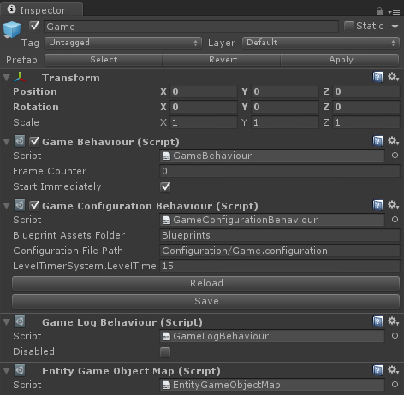

The first MonoBehaviour attached to the Game prefab is the *GameBehaviour*. This behavior is the main interface between Unity3D and your game logic. It holds a reference to one of your Game objects, and passes Unity Update calls to that game. Calling GameBehaviour.StartGame or ticking the Start Immediately checkbox will use your game configuration, your blueprints, and start the specified game.

The *GameConfigurationBehaviour* loads your blueprints and game configuration. This is done as soon as this behavior is enabled, for example when the scene is loaded. Note that this requires your files to reside in Resources folders. The GameBehaviour will pick up that data and pass it to your game.

You can even edit the game configuration in the Unity inspector. Add the *InspectorType* attribute to your system class, and other inspector attributes, such as *InspectorInt* or *InspectorString* to the properties you want to expose to the editor.

The *GameLogBehaviour* will automatically log all game events to Unity console. You might want to override the ToString methods of your event data objects in order to make this log output even more useful.

## Blueprint Editor

Remember when we were talking about entity blueprints and how they can be serialized to arbitrary data formats? Unity can do this for you. In Unity, click *Slash Games > Windows > Blueprint Editor*. The editor will try to find your blueprint file and provide a list of blueprints to edit. You can add new blueprints, or modify existing ones by selecting them and adding or removing components, or editing the attribute table.

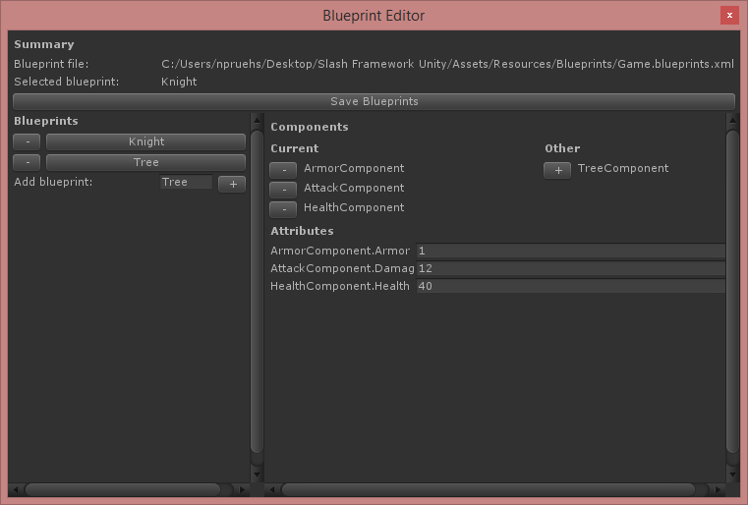

Note that you need to add the *InspectorComponent* attribute to your component classes, and other inspector attributes, such as *InspectorInt* or *InspectorString* to the properties you want to expose to the editor.

## Game Entities and Unity Game Objects

Usually, you’ll want to use Unity as your level editor. You can create a connection between your Unity game objects and your game logic by adding an *EntityConfigurationBehaviour*. This script will create a game entity using the selected blueprint and configuration.

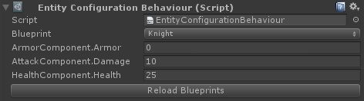

At runtime, you can access the id of the entity created by the script with the EntityConfigurationBehaviour.EntityId property. We will take a look at a code example for this in a minute. Furthermore, you might have noticed the EntityGameObjectMap script attached to the Game prefab. This behavior provides an indexer to access Unity game objects associated with given entity ids.

The inspector shows the entity id as well.

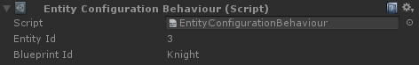

## Game Events and MonoBehaviours

Whenever the game state changes, you might want to update your visualization. The *GameEventBehaviour* is a great base class to extend if you want to listen to specific events:

[RequireComponent(typeof(EntityConfigurationBehaviour))]

public class PlayAnimationOnDamage : GameEventBehaviour

{

/// <summary>

/// Game entity associated with this Unity game object.

/// </summary>

private EntityConfigurationBehaviour entityConfigurationBehaviour;

protected override void Awake()

{

base.Awake();

// Get the game entity associated with this Unity game object.

this.entityConfigurationBehaviour =

this.GetComponent<EntityConfigurationBehaviour>();

}

protected override void RegisterListeners()

{

base.RegisterListeners();

// Register as listener for the DamageTaken event.

this.RegisterListener(RPGGameEvent.DamageTaken, this.OnDamageTaken);

}

private void OnDamageTaken(GameEvent e)

{

var data = (DamageTakenData)e.EventData;

// Check if it's us who's taken damage.

if (data.EntityId == this.entityConfigurationBehaviour.EntityId)

{

// Play hit animation.

this.animation.Play("HitAnimation");

}

}

}

You can override the RegisterListeners method to register as listener for specific game events. In this example, the game object will play an animation whenever the associated entity takes damage.